

RABIAMMAL AHAMED MAIDEEN COLLEGE FOR WOMEN,THIRUVARUR.

TEAM ID:NM2023TMID13568

PROJECT ID: A QUANTITATIVE ANALYSIS OF CANDIDATES IN THE 2019 LOK SABHA ELECTION.

TEAM LEADER: S.UVARANI

TEAM MEMBERS: G.VAISALI

J.K.VISVA PRIYA

E.INTHUMATHI.

INTRODUCTION: Our project is Quantitative analysis of candidates . Involving the Collection and analysis of candidates in laksh saba and other details are included in it.

PROBLEM DEFINITION &DESIGN THINKING

EMPATHY MAP

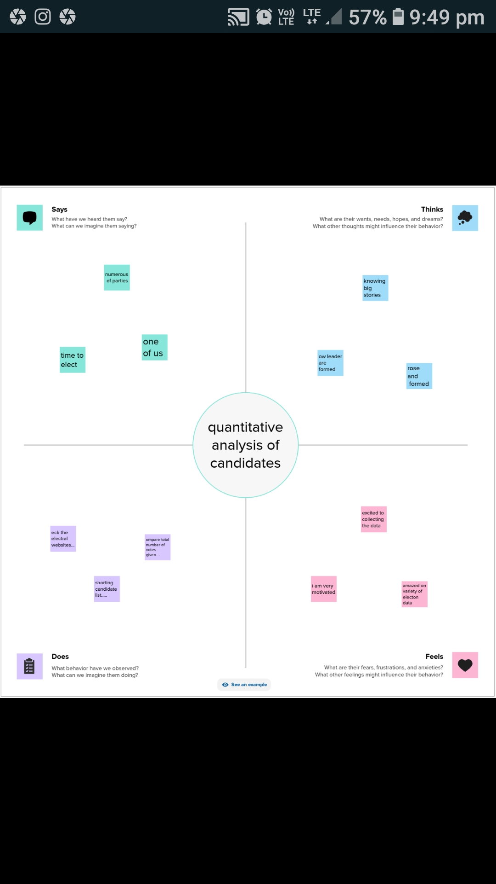

BRAINSTOMING MAP

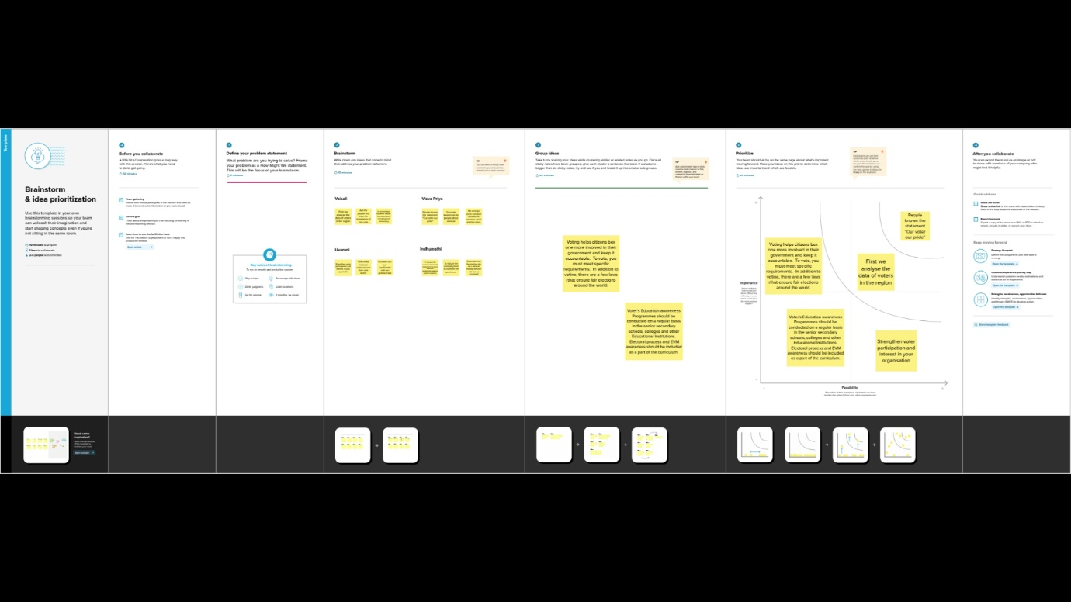

RESULT:

Final finding (output) of the project along with screenshort.

GENERAL VOTES ANALYSIS:

By the analysis of general votes in both female and male the highest votes registered by post graduates

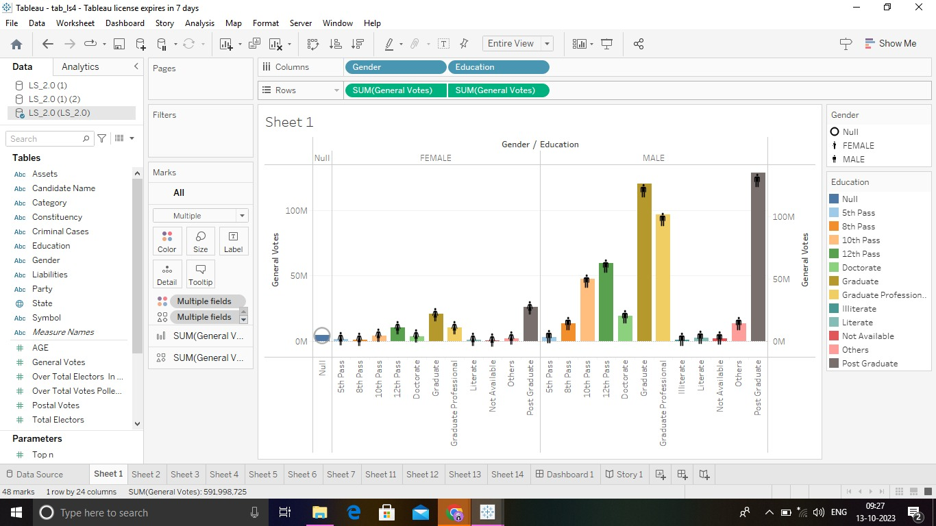

CONSISTENCY ANALYSIS:

The analysis of Total Electors and winner is clearly shown in a graph

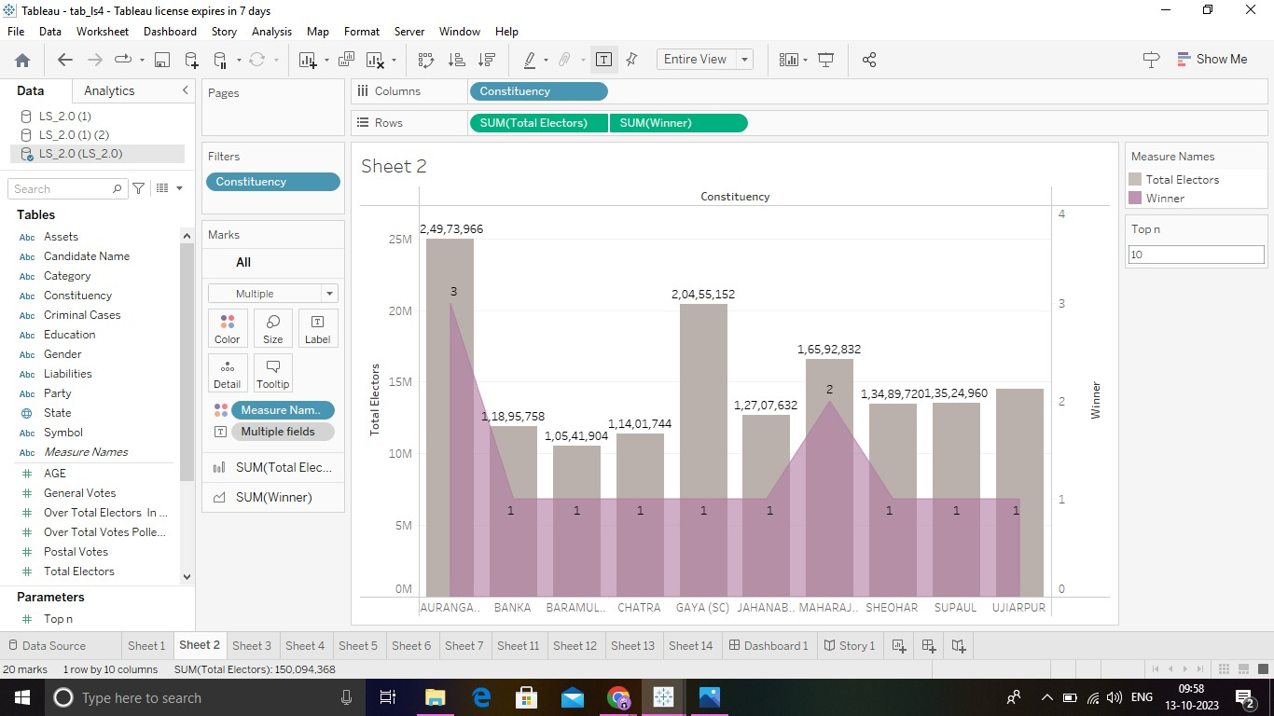

PARTY WISE ANALYSIS:

We created two pie graphs and make the below visual for party.

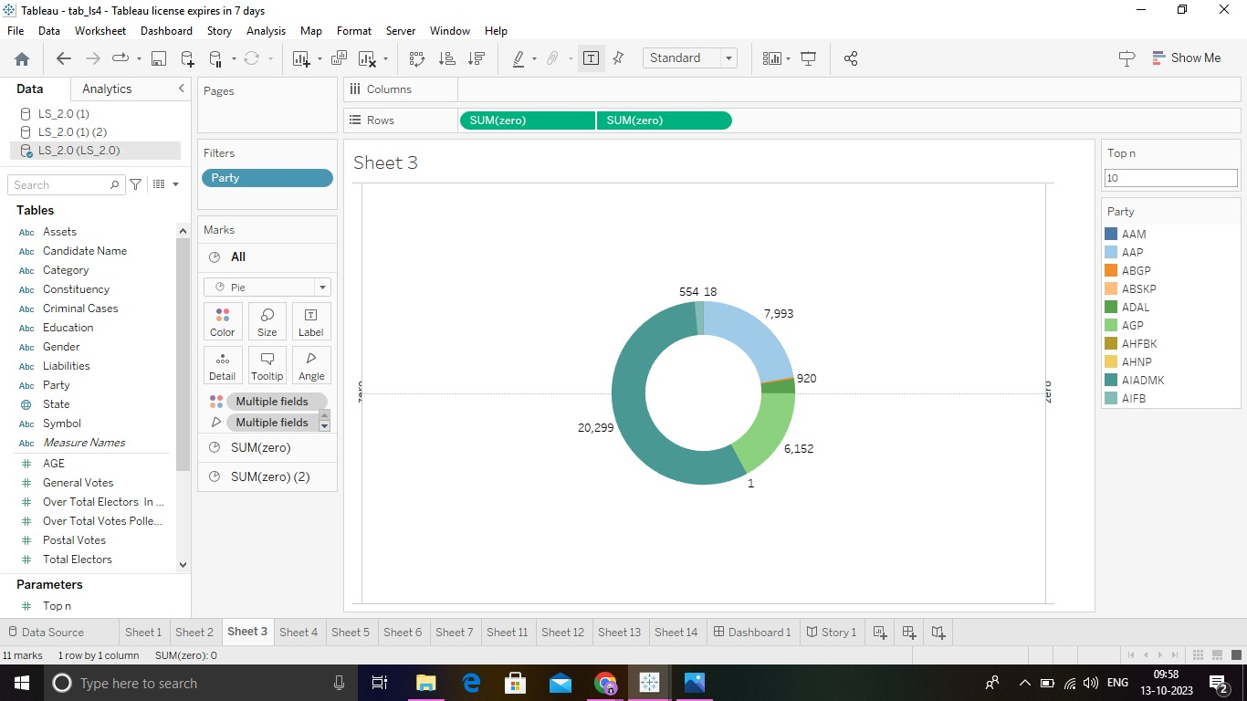

STATE WISE ANALYSIS:

The ste wise winners are filtered and modified as a display graph

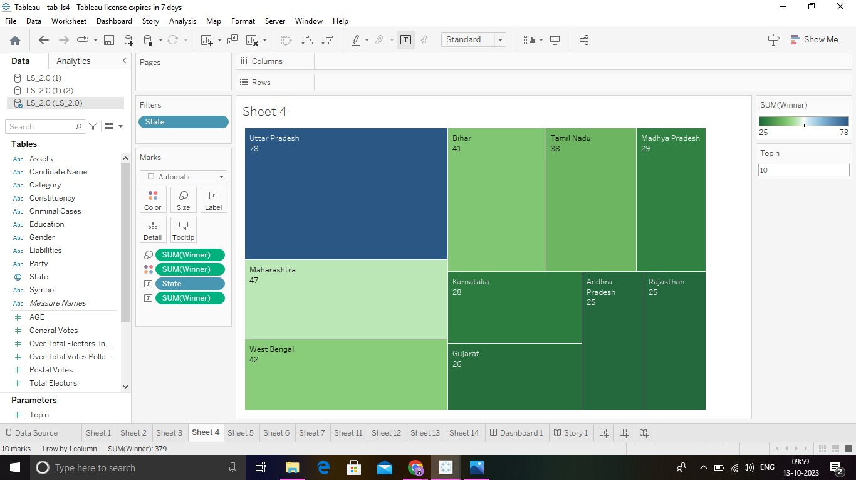

STATE WISE VOTES:

In this bar graph we make a votes of postal and general by add a zero in centre.

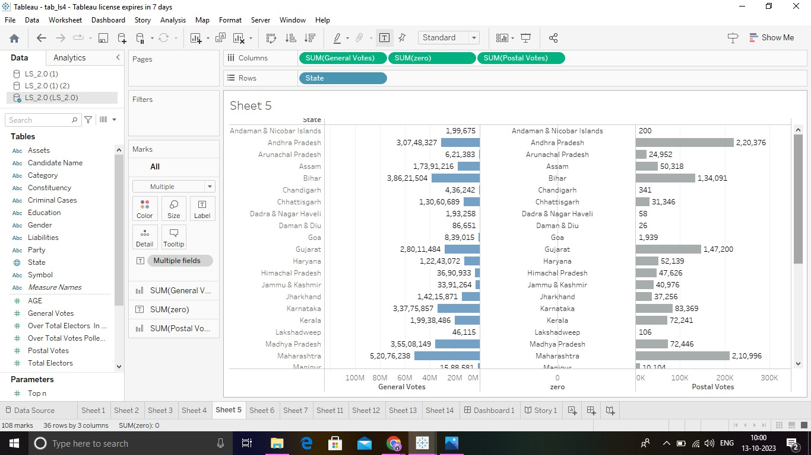

PARTY WISE WINNERS:

In this spare we arranged a graph of part wise winners which BJP had the highest.

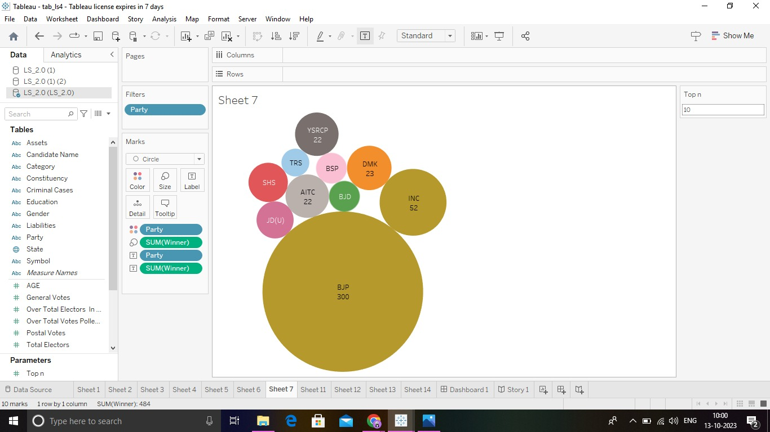

WINNERS BY EDUCATION AND CATEGORY:

The analysis of winners by Education are displayed as a table format below.

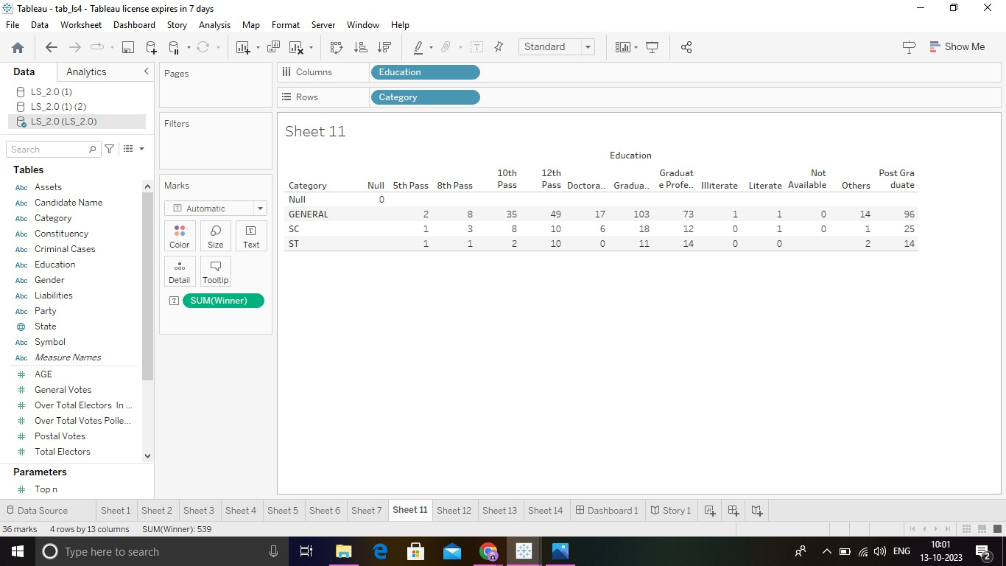

TOTAL WINNERS:

The total winners are viewed in entire view mode which is 539.

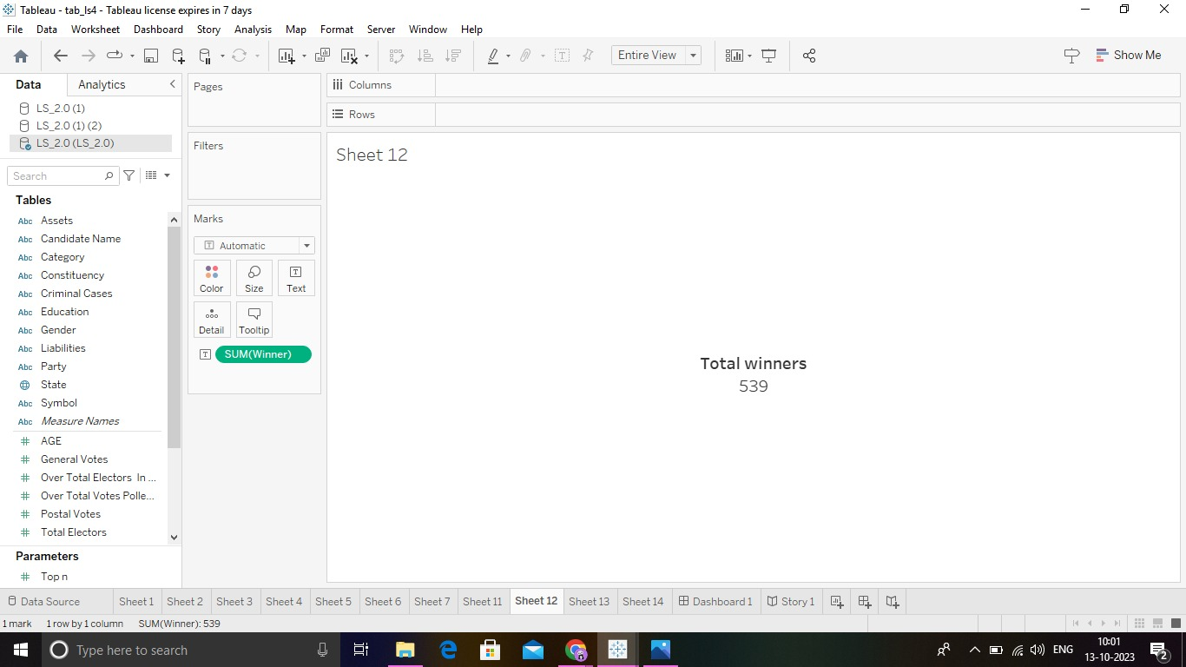

TOTAL CRIMINAL CASES:

The total criminal cases are viewed in entire view mode which is 2,018.

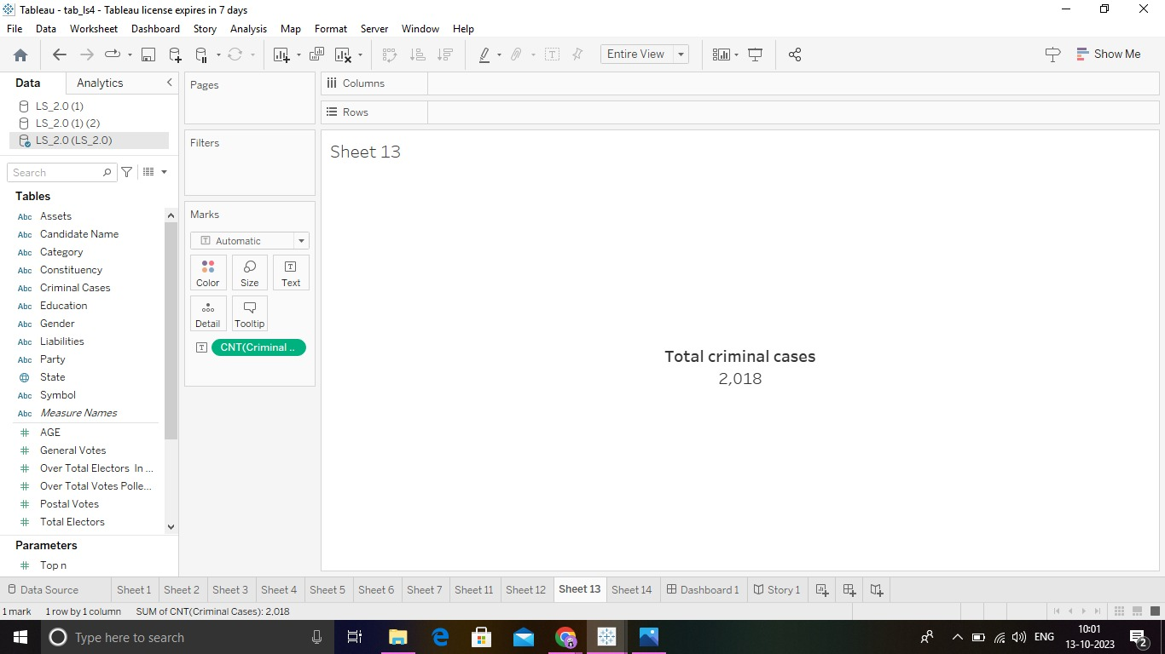

TOTAL VOTES:

The total Votes are viewed in entire view mode which is 59,42,40,703.

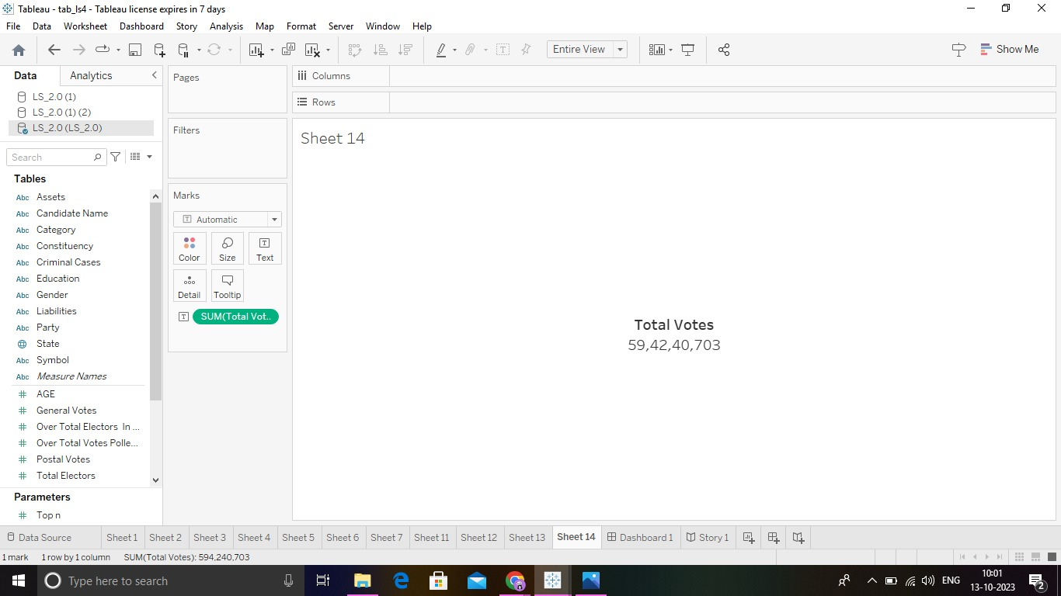

DASHBOARD:

we made the responsive and design of dashboard by adding all of worksheets.

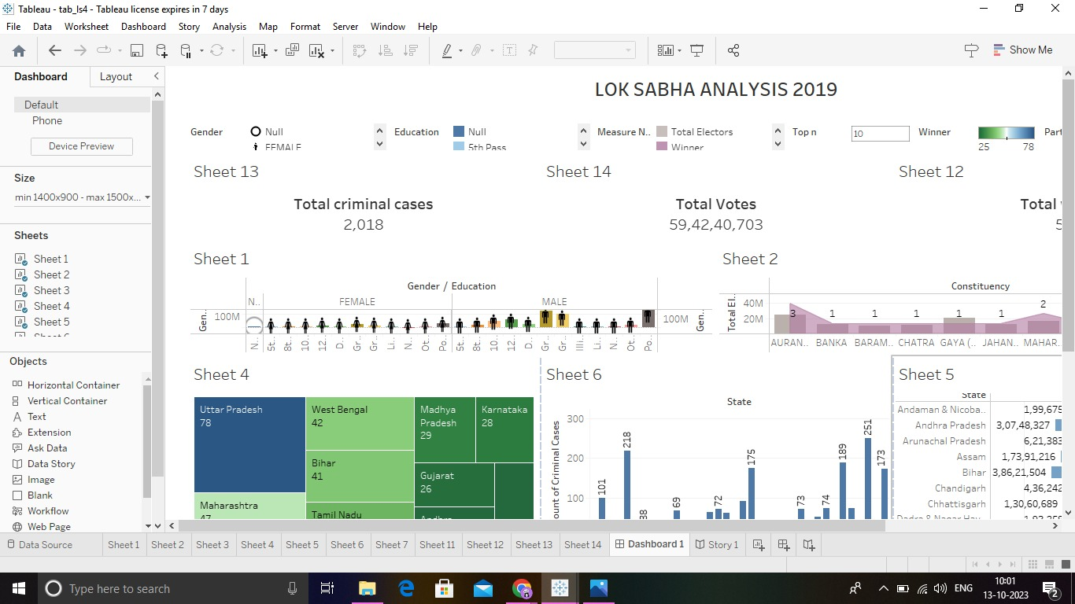

STORY:

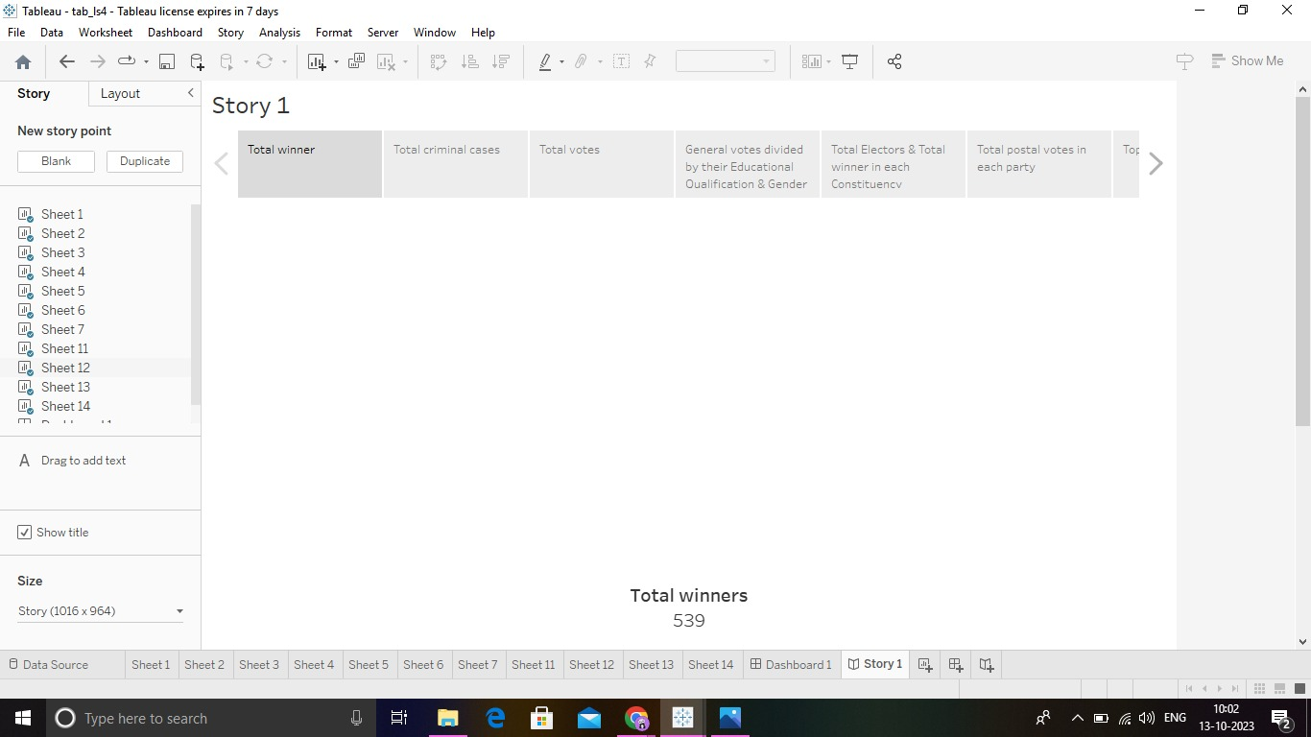

CONCLUSION:

Quantitative research uses a variety of statistical analysis methods to derive quantifiable research conclusions. These are based on mathematical processes applied on the gather data.

TABLEAU PUBLISHED &SCREEN Shots

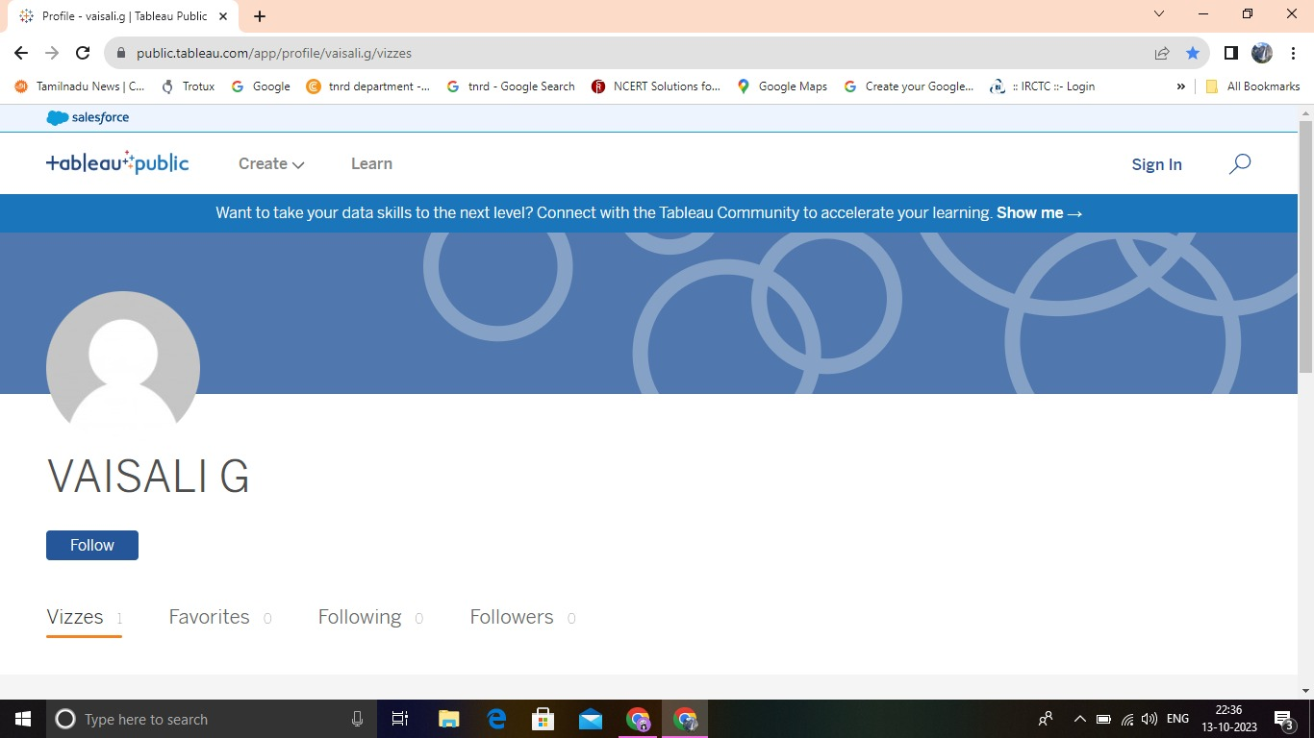

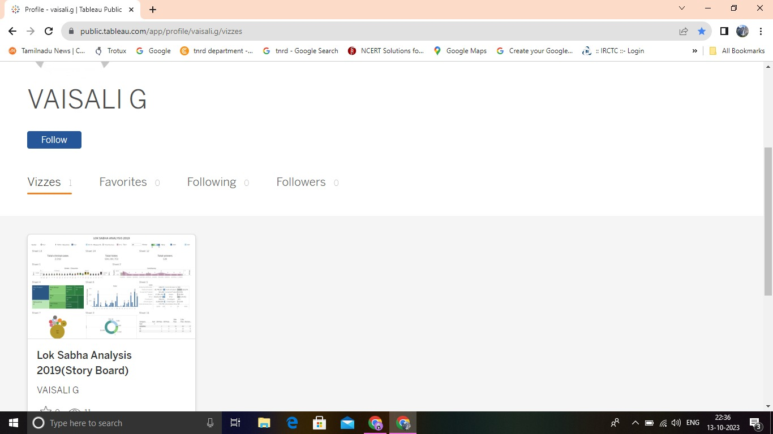

PUBLISH LINK:

<https://public.tableau.com/app/profile/vaisali.g/vizzes>.

TEAM ID:NM2023TMID13568.